**SOP FOR**

1. **PURPOSE: :-       Safe maintenance of mudgun for optimum performance  .**
2. **SCOPE:** **Blast Furnace Accessories** .
3. **RESPONSIBILITY: :-       Engineer In charge.**
4. **PROCEDURE: MAINTENANCE OF MUDGUN .**

PPE s  to be used:         Helmet, Safety shoes, Cotton cloth, hand gloves and goggles, ear plug

LIST OF TASKS COVERED

Work No 1 : Mud gun centering

Work No 2 : Replacement of mudgun barrel assembly

Work No 3   : Replacement of mudgun piston liner

Work No 4   : Replacement / Opening of mudgun nozzle

Work No 5  : Replacement of hoses

Work No. 6 : Lubrication of Mudgun

Work No. 7 : Barrel Cooling Water Jacket Repairing / Replacement

Work No. 8 : Replacement of Mudgun Pushing Cylinder with cover replacement

Aspect Impact

|  |  |
| --- | --- |
| Scrap generation | Resource Depletion |
| Oil Spillage | Land contamination & Resource Depletion |
| Oil traced waste generation | Land contamination & Resource Depletion |

Hazards identified

**Mechanical Hazard**

1. Trapping in between parts, weights, moving components.
2. Impact of hammer, weights, mudgun, etc.
3. Fall of objects such as hammer, barrel, piston, nozzle, etc.
4. Fall of person from height.
5. Entanglement while replacing the hose
6. Pressure of oil during sudden removal of hose in pressurized condition.
7. Hitting of Mudgun due to failure of the direction control valve

**Physical Hazard**

1. Burn injury from metal, runner, and furnace.
2. Pressure from hydraulic system, furnace, etc.

**Behavioral Hazards:** working without all required PPE’s

Working under influence of alcohol

Horse play

Casual approach

Not following SOP/WI while carrying out the job

Work No: 1 : Mudgun centering

**For Horizontal adjustment**

1. Take the permission from cast house engineer to work on centering of mudgun. Loosen the turnbuckle lock nut.
2. Swivel the mudgun near the taphole and ensure that clay is filled in the barrel.
3. Remove the field key located adjacent to the mudgun. (powerpack shutdown cannot be taken for checking the centering more than one time).
4. Adjust the turnbuckle bottle by rotating with hand as per requirement . In case if it is not possible to rotate by hand then 20mm rod can be inserted into the hole provision available on turnbuckle to facilitate free rotation.

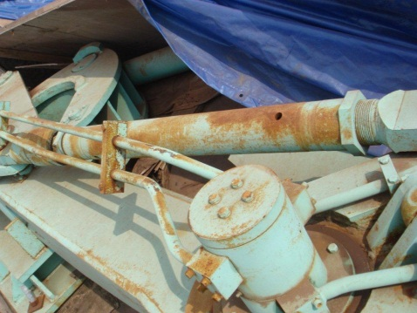

1. Once centering is achieved tighten the lock nuts .
2. Insert the field key and release the push button.
3. Take mudgun swiveling trials and give clearance.

**For Vertical Adjustment**

1. Loosen the 2 allen bolt located on the turnbuckle connecting mud barrel.

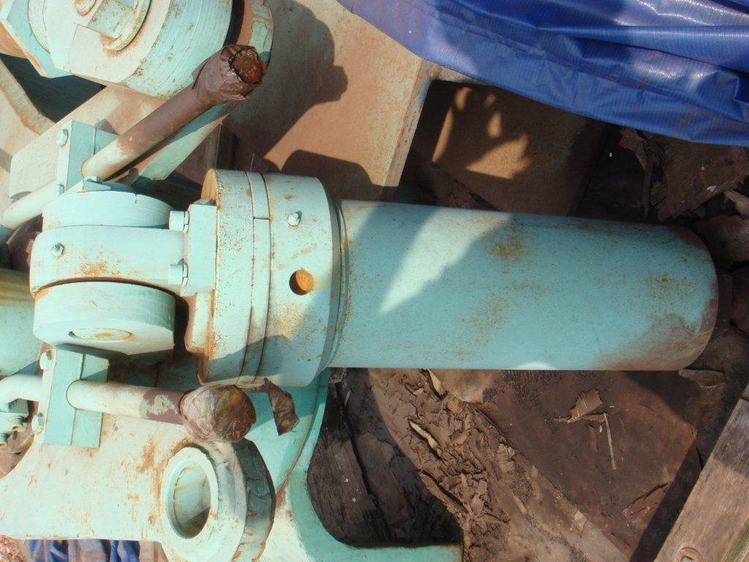

1. Rotate the bottle as per requirement and take mudgun trial 2 times.
2. If vertical adjustment is achieved then lock nuts to be re tightened .

Work No 2: Replacement of mudgun barrel assembly

1. Take clearance from production.
2. Empty the clay from the barrel by operating the injection cylinder & keep piston in backward position.
3. Take shutdown of mudgun power pack.
4. Close the valves & Put isolation LOTO
5. Use 16 ton crane to take load of barrel while dismantling the mounting flange bolts.
6. Once theflange bolts are removed , slowly lower the barrel and shift it aside.
7. Now mount the new/overhauled mud barrel to the mudgun.
8. Tighten the bolts of mounting ~~brackets.~~ Flange bolts.
9. Release the load from 16Ton crane.
10. Clear the shut down and take trial.
11. Carry out centering as per Work no.1 if needed

**Work No. 3 Replacement of mudgun piston liners .**

1. Take clearance from production dept.
2. Ensure that the mud barrel is completely empty and piston is in its retracted position.
3. Now take shutdown of mudgun powerpack.
4. Using 16 ton crane lower the first nozzle and than reducer by loosening the flange bolts.
5. Now remove the front 2 nos. piston locking nuts & front retaining plate.
6. Now slide the 2 nos. worn out liners (Nylon66 & Cast Iron ring) from piston periphery & replace with new ones.
7. Ensure the proper direction of seals while assembling.
8. Fit back the retaining plate and tighten the 2 nos. piston locking nuts.
9. Fit back the first reducer and than nozzle.
10. Clear the shut down & take injection trial .
11. Remove LOTO & Open hydraulic lines valves
12. Check for any obstruction of piston during forward & reverse stroke .
13. Give clearance to production dept.

**Work No 4 : Replacement / Opening of mudgun nozzle**

1. Take clearance from production department cast house engineer.
2. Take electrical shutdown powerpack.
3. Remove the field key located adjacent to the mudgun.Use 16 ton crane for lowering the mudgun nozzle.
4. Wrap a sling around the nozzle & connect it to 16 ton crane hook and ensure load is taken by hook.
5. Remove 2 nos
6. Clean the nozzle seat area
7. Replace the nozzle with new or cleaned nozzle and tighten the flange bolts / tighten the 2 bolts and nut .
8. Clear the electrical shutdown of powerpack.
9. Fill the clay in barrel and take trail by operating piston liner and check for any leakage.

**Work No 5 : Replacement of hoses**

1. For changing the hoses ensure that mudgun assembly is located at extreme back position.
2. Ensure that Mudgun operator has switched off pumps .
3. Remove the field key located adjacent to the mudgun.
4. Close the isolation valves at DC valve outlet & Put isolation LOTO.
5. Slowly loosen the fittings to release the hydraulic oil pressure and collect the oil in empty container. Care should be taken to prevent the oil from falling on the ground. Use bucket to collect the oil from Hoses.
6. Replace the damaged hose with new one. Replace the O ring if required.
7. If changing more than one hose at particular place MS pipe of oil should be mark to understand proper connection of hose according to its operation:
8. Check the hoses end fittings are matching to hose nipple in case of flat seals.
9. Hoses are to be fitted without twisting and entanglement.
10. Remove isolation LOTO & open the valves
11. Take the trial of the mud gun. Attend the leakages if any
12. Give clearance to the production by clearing work permit.
13. Ensure house keeping
14. Shift old used grease & waste clay (used for trial) to respective scrap bin to return to store.

**Work no. 6 : Lubrication of Mudgun**

1. Take clearance from cast house in charge & operator.
2. Remove the field key located adjacent to the mudgun.
3. Lubricate the machine as per pre identified points.
4. Fix back the field key and give clearnace.

**Work No. 7**: Barrel Cooling Water Jacket **Hose/Pipeline/bottom cover plate/water coil** replacement

1. Take clearance from production cast house engineer.
2. Ensure the cast is close & mudgun is located at extreme back position.
3. Take electrical shutdown of hydraulic pumps and take work permit.
4. Close the barrel cooling waterline shut off valve.
5. Remove the field key located adjacent to the mudgun.
6. Close hydraulic line shut off valves of Mudgun swiveling lines & pushing line& put isolation LOTO.
7. Close hydraulic line shut off valves of Drill Machine Main operating Strand Pressure Line & Return Line & put isolation LOTO.
8. Disconnect waterline from water jacket
9. Remove Barrel protecting cover plate
10. Remove water jacket
11. Repair / replace water jacket/ Hose/pipe/bottom cover plate (Don’t forget to put ceramic wool on both the sides of water jacket).
12. Re fixing water jacket bottom plate
13. Connect water line with water jacket
14. Open waterline shut off valve & check water leakage from joint.
15. Remove isolation LOTO & Open hydraulic line shut off valves of Mudgun swiveling lines & pushing line
16. Remove isolation LOTO & Open hydraulic line shut off valves of Drill Machine Main operating Strand Pressure Line & Return Line
17. Clear electrical shutdown and Work Permit
18. Put back field key

18. Take trail by authorized mudgun operator

19. Hand over the equipment to production .

**Work No. 8**: **Replacement of Mudgun Pushing Cylinder with cover replacement**

1. Take clearance from production cast house engineer.
2. Empty the clay from the barrel by operating the injection cylinder & keep piston in backward position.
3. Ensure Mudgun back to its parking position (extreme back)

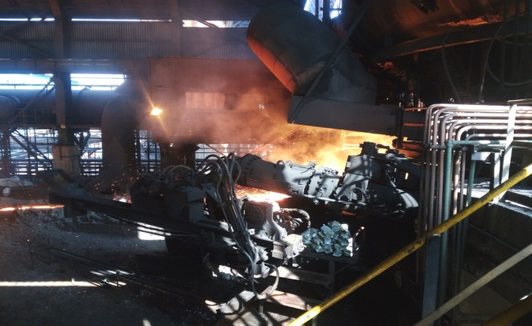

Keep Mudgun in this position

1. Take electrical shutdown of all three motors of hydraulic pumps.
2. Close all the shut off valves of hydraulic power pack strands of Drill Machine & Mudgun and fix LOTO
3. Remove both the injection hoses & loop both the cylinders ports with hose pipe.
4. Remove both the injection hoses, hoses should be mark according to forward and reverse direction of MG swiveling so that hoses can be fitted correctly according to its operation.
5. Place a chain pulley block (3ton capacity) bellow the Cast House crane walkway (opening to be made for the same)

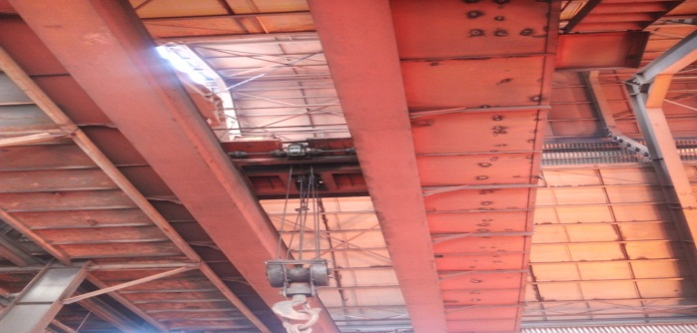

Place 3T chain pulley block here

1. Remove Mudgun nozzle with Cast House Crane
2. Take load of Clay barrel to 16t Cast House Crane chain pulley block

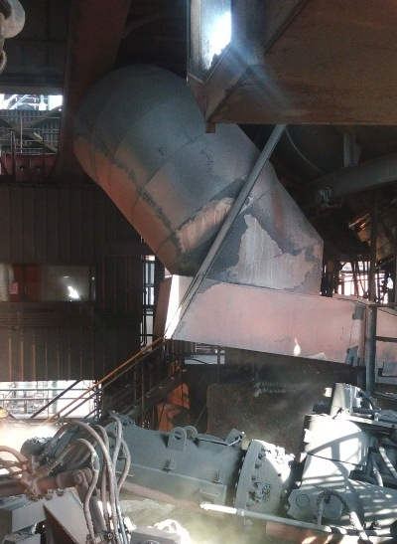

Clay barrel holding hook

Fix Chain Pulley Block for lifting Clay barrel

1. Close shutoff valve of Barrel cooling waterline
2. Remove barrel cooling waterline hoses
3. Remove Clay barrel cooling jacket and SS coil
4. Make match line with clay barrel to pushing cylinder barrel flanges

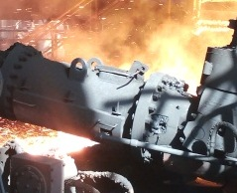

Clay barrel holding bolts

Punch matching points

1. Remove Clay barrel holding bolts (if gas cutting is required follow work instruction SP 44)
2. Once the bolts are removed, slowly lower the Clay barrel and shift it aside.
3. Withdrawn electrical shutdown of Mudgun power pack motors
4. Open shutoff valves of Drill Machine swiveling cylinder lines.
5. Ensure operating field key are ON condition
6. Place Drill machine towards taphole
7. Take electrical shutdown of all three motors of hydraulic pumps.
8. Close shutoff valves of Drill Machine swiveling cylinder.
9. Remove both the swiveling line hoses & loop both the cylinders ports with hose pipe of Mudgun.
10. Remove barrel cooling water jacket hoses.
11. Remove Mudgun Pushing Cylinder protecting water jacket with cover plate.
12. Use 5T capacity or higher capacity belt sling at Cast House Truss (build up beam) just above the Mudgun Pushing cylinder center line.

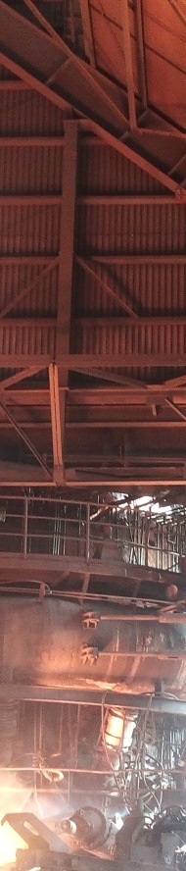

Fix Chain pulley block here

Fix Belt sling here

Hang belt sling or rope sling up to pushing cylinder top

1. Use Wire rope or belt sling at rated capacity of ≥5 ton from Truss to Pushing cylinder above.
2. Fix a Chain pulley block (Capacity 5 T) on hanging sling from Truss.
3. Measure the pin center to center distance of vertical turnbuckle & keep a note on a paper

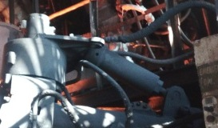

Vertical Turnbuckle pins center distance

1. Now take the load of Pushing Cylinder to the vertical mounted Chain pulley block
2. Remove vertical turn buckle barrel side pin
3. Tie vertical turnbuckle with manila rope to Four-poster support structure
4. Tie Pushing cylinder barrel with Manila rope (20mm dia) horizontally.
5. Remove trunnion bracket bolts on both sides of the barrel.



Trunnion bracket bolts

1. Place Cast House crane near Mudgun to take pushing cylinder barrel out from trunnion by cross pulling towards PCM through chain pulley block which is placed at cast house crane platform.
2. Take the Pushing cylinder barrel out of the trunnion brackets with operating Chain pulley block & crane (as per requirement).
3. Now release the load from crane side chain pulley block & swing pushing cylinder barrel perpendicular to the Main runner
4. Remove Mud level indicator mechanism (if require)
5. Gradually lowering the barrel to the ground & take aside.
6. Place reconditioned/new pushing cylinder barrel at the bottom of vertical chain pulley block.
7. Hoist the Pushing cylinder barrel up to the bracket level.
8. Take the load to 16 ton crane chain pulley block for cross pulling.
9. Now put back pushing cylinder barrel into the bracket with operating both the chain pulley blocks (as per requirement)
10. Fix vertical turnbuckle & ensure its pin to pin distance (that you have noted)
11. Gradually release the load of vertical chain pulley block after full tight the bolts & check nut of M24 x 260 studs.
12. Fit Mudgun indicator mechanism back
13. Fit Pushing cylinder cooling water jacket with bottom plate.
14. Take the load of clay barrel to Cast house crane chain pulley block
15. Hoist the clay barrel & position it to the mounting flange
16. Match the punch line, fix the bolts & full tight the bolts
17. Release the load from cast house chain pulley block
18. Put the clay barrel cooling water jacket back
19. Connect clay barrel cooling waterline hose
20. Put back nozzle with cast house crane & tight the bolts

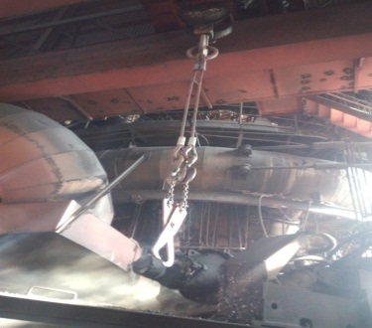

Mudgun Nozzle

1. Connect hoses of Mudgun swiveling cylinder & pushing cylinder
2. Open barrel cooling water line valve.
3. Remove all the loose parts, tools,tackle & oil tray from Mudgun area
4. Release electrical shutdown of hydraulic power pack motors
5. Open all the shutoff valves of (valves strand) Mudgun & Drill Machine
6. Release the Work permit & handover the Mudgun for operation.
7. Take trail by authorized Mudgun & Drill machine operator
8. Confirm Mudgun centering with SS & Cast House production in charge

 DO :

* Wear gloves, goggles while working at cast house area.
* Take necessary precautions while working in cast house as it is a hot metal handling area.
* Take necessary care while handling items, which are smeared with grease and oil.
* Ensure nobody is within the swing area of mudgun while taking trial.
* Collect oil in tray of the hose pipes.
* Use proper slings while dismantling.
* Put a grating on main runner in case you are working on runner side.

# DO NOT :

* Wear gum boots while working in cast house.
* Take trial of the machine yourself. Only cast house operators and engineers are authorized to operate the mudgun.

**REFERENCES: Operation & Maintenance manual.**

**Amendement Record**

|  |  |  |  |
| --- | --- | --- | --- |
| **Date** | **Manual Section Ref. & Para** | **Brief details of Revision** | **New Rev.** |
|  |  |  |  |
|  |  |  |  |
|  |  |  |  |

|  |  |  |
| --- | --- | --- |
| **Prepared By:**  Digital head VAB | **Reviewed & Issued By:**  Management Representative | **Approved By:**  Mechanical and Asset Integrity Head VAB |
| **Signature:** | **Signature:** | **Signature:** |
| **Review Date: 15.08.2023** | **Review Date: 15.08.2023** | **Review Date: 15.08.2023** |